# Prototypes

## Question 1

Do I need a break?

### Test

Put task and how long at it and if not making progress, if more then allotted time move on.

### Results

Looks like the sticky notes are in view and kind of working. I have found myself looping on mindless tasks after an hour or 2 but was here for 3 hours and need a break.

Next task will set allotted time to complete task and stop every hour.

## Question 2

Would it be easy to make a new level, or should I reuse their one?

### Test

Duplicate scene and see if you are able to easily change tiles.

### Results (20 mins estimation)

Actual - 35 Minutes

Found out needed Tile Editor downloaded and then created a simple level. Was easier than expected despite me taking longer than estimated.

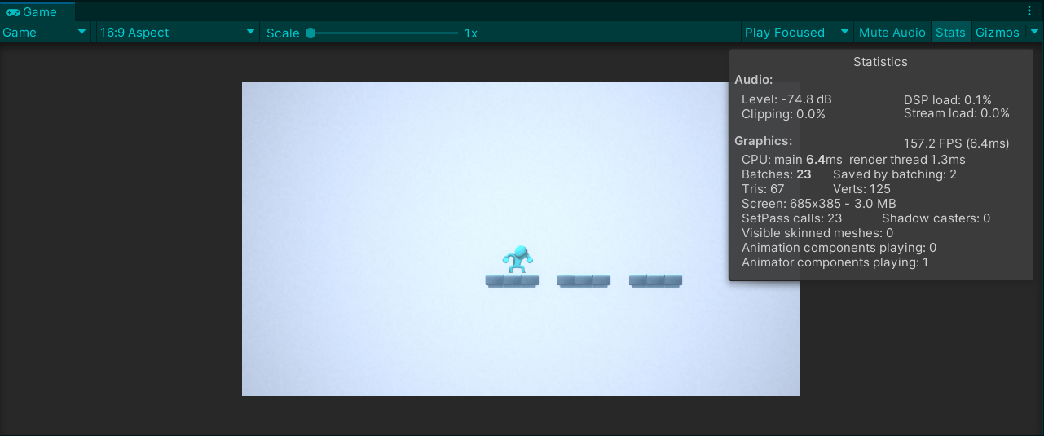

## Question 3

Am I able to easily reload level but remove a layer?

### Test

See if can make a level with 3 platforms, when player reaches end point see if can:

1. Die
2. Respawn
3. Change end goal (probs make not interactable for a second)
4. Remove the middle platform
5. When hit end go to the Main Menu.

### Results (40 mins estimation)

Actual - 1hour 30 min

So, this came down to me trying to use the code in the asset in the way it was intended.

I should have prioritised time for completing this project rather than keeping the code clean.

In most cases following the code would be the correct approach but it should not have been the case in this project as completion time is a higher priority.

**Learnt – I should break down tasks into smaller steps to press play after each one is complete.**

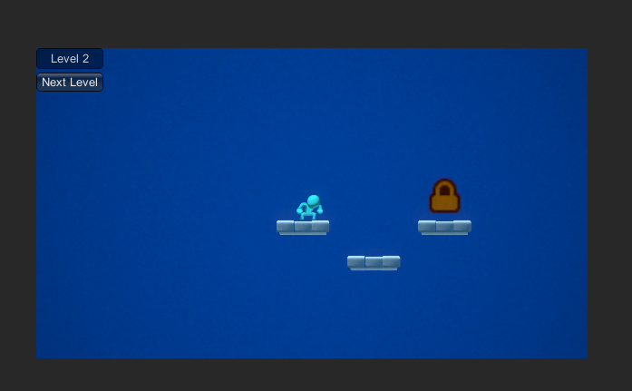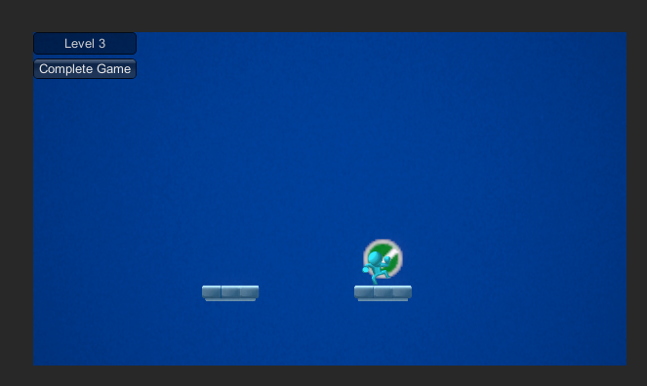

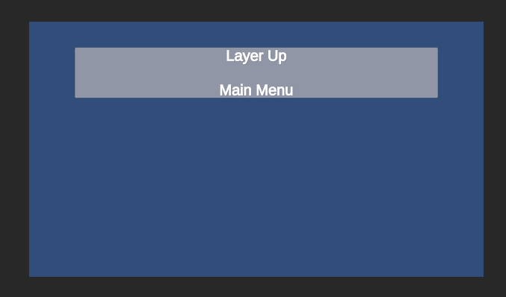

## Final Lessons

Need to create playable demo.

Currently I have blocked all forms of communication, so I didn't focus on getting a playable demo for others.

I learnt I should be breaking down problems and pressing play more often.

Also learnt that the aesthetics in the original asset make up a large part of the immersion.

I need to find a way to either find a new asset for the environment OR change the idea of the game.

I think with the name and playing with the assets it might be interesting if layers were removed or filtered.

Whichever way forward I think background layers could be linked to the playable level (such as clouds mountains and trees) and added or removed as other layers are.

Final takeaway is the gameplay feel being ‘fun’ is top priority.